CSE 460 Programming Assignment

Software Engineering Concentration

Computer Science Program

Arizona State University, Tempe, AZ

Posting ID: 0530-277

Spring 2018

**Assumptions**

1. Class Diagrams

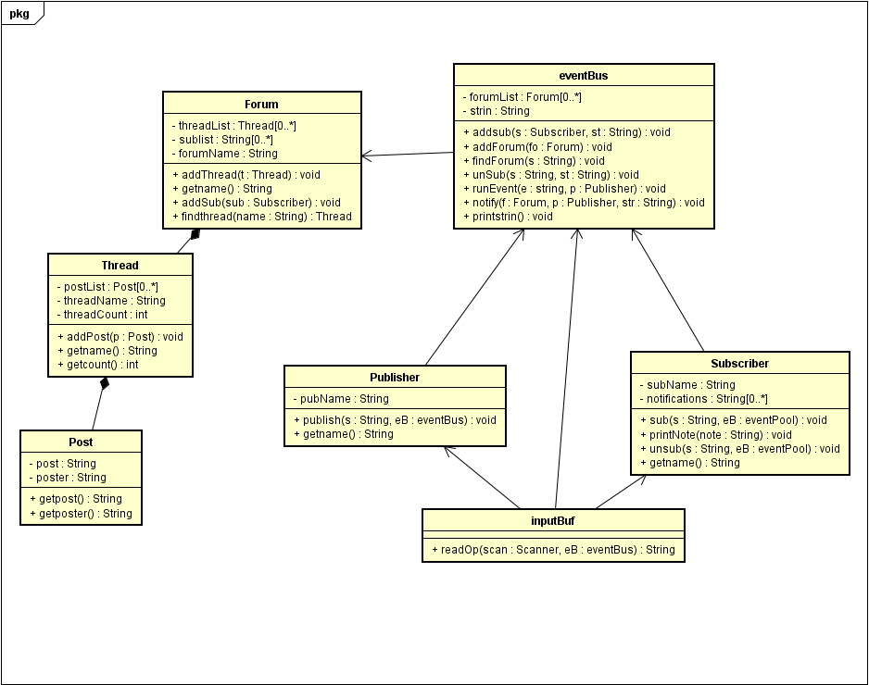

The program is run by a main function that continues to run until whichever file is finished inputting each line, The inputBuff will then create an appropriate class, publisher or subscriber and send to the EventBus what to do and the components needed to do it. The EventBus then houses a forumlist incase multiple forums are created, and has complete access to the subscribers to each forum, the threads and posts within each forum as well. If a publisher posts something it will add the post to the appropriate thread, and then send out notifications to each subscriber within the sublist. Everything depends on the eventBus as the publishers and subscribers are sending it the notifications of what to do. The publishers and subscribers only send information, and the subscriber only receives information from the eventBus that the eventBus deems necessary.

1. Sequence Diagrams

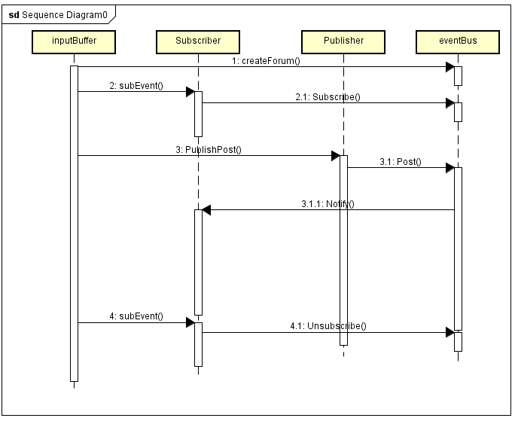

This is a basic sequence of events for one forum creation, one subscription and one publication, and finally an unsubscription and what affects what in each order.

1. State Machine Diagrams

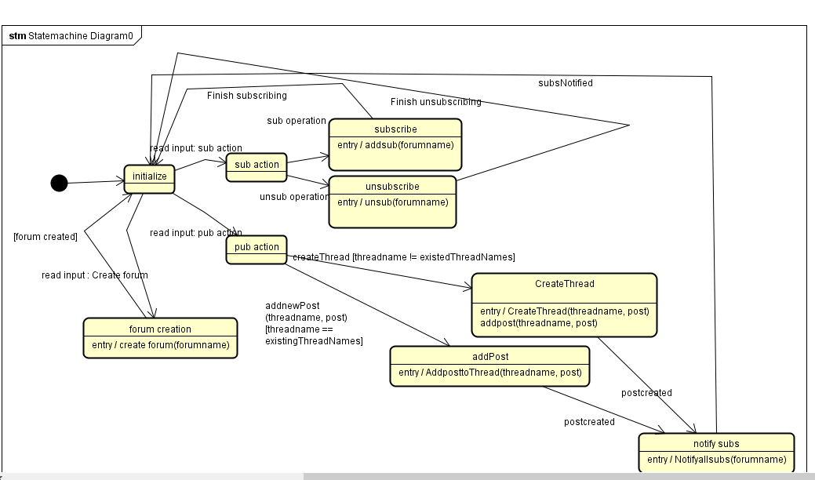

This is a basic state machine, that continues forever.

1. Readme

The submission contains all classes as well as the report and the main class is Main.java, The text files only needs to be run through Main.java.

Appendix

This section is for including any supporting material you may have.